**Maharshi Patanjali Vidya Mandir Prayagraj**

**HOLIDAYS HOME WORK**

Of

**Class XI-Mathematics Stream**

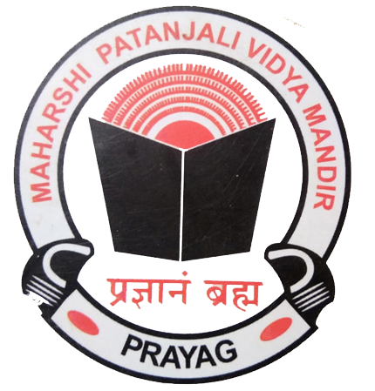

"Education's purpose is to replace an empty mind with an open one."

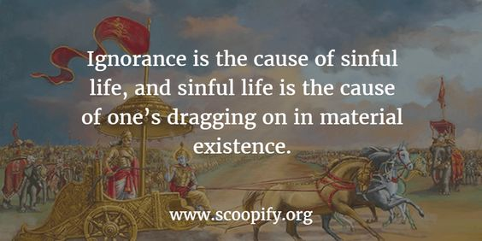



|  |  |
| --- | --- |
| **English** | Learn the Question and answers of the following lessons:-  **HORNBILL**   1. The Portrait of a Lady  * A Photograph (poem)   **SNAPSHOTS**   1. The Summer of the Beautiful White Horse   **Practice the exercises on the given topic in**  **Grammar:-**  1.Tenses  **Make a video in pairs, on the topics given:-**  ( please follow these Instructions :-)  *Video should be of 1 minute 30 seconds duration and have to be sent in a compressed format.  * You will speak only on the topics given.  * Keep the video safely as you have to send it to the teachers in July.  **TOPICS FOR ONE AND A HALF MINUTE CONVERSATION**  1.Trying times  2. How to increase our immunity  3. Time Management  4. How I miss my school  5. My Ideal  6. Unpolluted nature- lockdown-lesson  OR  ROLEPLAY: TOPICS (Individual) Keep a hardcopy of the script   1. Policeman 2. Doctor 3. Journalist 4. Army Personnel 5. Teacher 6. Businessman |
| **Mathematics** | 1. Solve the questions of Set Theory from NCERT and the reference book.  2. Make a list of all the formulae studied in class 10th.  3. Revise the concepts of Algebra and Trigonometry studied in class 10th. |
| **Physics** | (Questions to be answered in short with diagrammatic representation if required)  Q. 1 Illustrate the practical applications of elasticity in the following examples:- I) bridges and II) cranes/lifts → their design feature and concept of elastic fatigue  Q. 2 Illustrate the biological connection of capillarity as used in paper chromatography.  Q. 3 Discuss any two practical uses or consequences of surface tension/angle of contact.  Q. 4 Geosynchronous satellite vs Polar satellite → Compare their differences and uses.  Q. 5 Discuss Bernoulli’s principle as used in case of  I) atomizer/sprayer  II )Magnus effect |
| **Chemistry** | (1)Do numericals from the mole concept studied in the class.  (2) Revise the chapter some basic concepts in chemistry.  (3) Write short notes on the discovery of electron, proton and neutron.  (4) Write short notes on the topics of environmental chemistry. |
| **Informatics Practices** | Write down the answers of the following questions.  1. What do you understand by cross platform language/software? Is Python a cross platform language?  2. What are the different working modes in Python? Explain.  3. What are the literals in python? How many types of literals are allowed in python?  4. What is single line string and multi-line string? Explain with example?  5. What is dynamic typing?  6. What will be the output produced by the following code : X=10 X=X+10 X=X-5 Print(X) X,Y = X-2, 22 Print(X, Y) X, Y = 20, 60 Y, X, Y = X, Y-10, X+10 Print(X, Y)  7. Write a python program that accepts marks of five subjects as input and produce average of marks as output.  8. A=10 B=20 Write a program to swap the value of A and B by using third variable and print the value of A and B. |
| **Physical Education** | 1. Revision of unit I 2. Make shorts notes of various topic – (athletic, basketball, football) 3. Practice of Asana ( tadasana, padmasana, Shashankasana) 4. Practice of meditation 5. Practice of home yoga fitness workout daily. |
| **Hindi** | पढ़ाई गई कविताओं का शिल्प सौंदर्य लिखिए  2- गद्य खंड के प्रश्न उत्तर लिखिए एवं याद कीजिए  3- कोरोना संकट से बचाव का सुझाव देते हुए किसी प्रमुख समाचार पत्र के संपादक को पत्र लिखिए  4- सबको मिले शिक्षा का अधिकार विषय पर एक अनुच्छेद लिखिए |
| **Economics** | 1. Revision of unit I 2. Make shorts notes of various topic – (athletic, basketball, football) 3. Practice of Asana ( tadasana, padmasana, Shashankasana) 4. Practice of meditation 5. Practice of home yoga fitness workout daily |
| **Legal Studies** | 1. Read unit I from the CBSE e book sent to you 2. Do all the objective type questions of chapter 1 and 2 from the CBSE book 3. Revise what was done in the class 4. Make the legal Studies project 5. Guide lines for the project 6. Make a project on any fundamental right   It should include the following headings  Article- Its words, meaning, commentary  Explanation of the Right  Decided cases explain the Right |
| **Computer Science** | 1. Operators &amp; types: Binary operators-Arithmetic, Relational  Operators, Logical Operators, Augmented Assignment Operators.  2. Execution of a program, errors- syntax error, run-time error and logical error.  3. Conditional statements: if, if-else, if-elif-else;  4. Notion of iterative computation and control flow: for(range(),len()),  while, using flowcharts  5. Strings: Traversal, operations – concatenation, repetition,  membership; functions/methods–len(), capitalize(), title(), upper(),  lower(), count(), find(), index(), isalnum(), islower(), isupper(),  isspace(), isalpha(), isdigit(), split(), partition(), strip(), lstrip(),  rstrip(), replace(); String slicing**.** |

“The aim of education should be to teach us rather how to think, than what to think — rather to improve our minds, so as to enable us to think for ourselves, than to load the memory with thoughts of other men.”

What we learn with pleasure we never forget.”

“Education is the passport to the future, for tomorrow belongs to those who prepare for it today.”

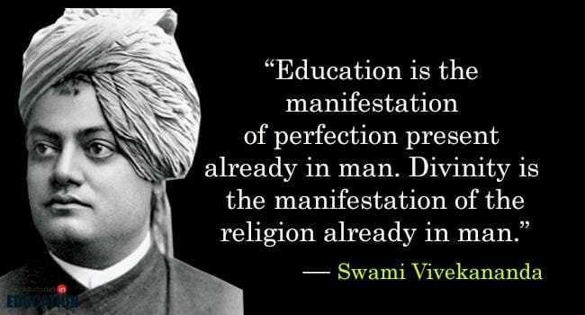

ENJOY YOUR HOLIDAYS